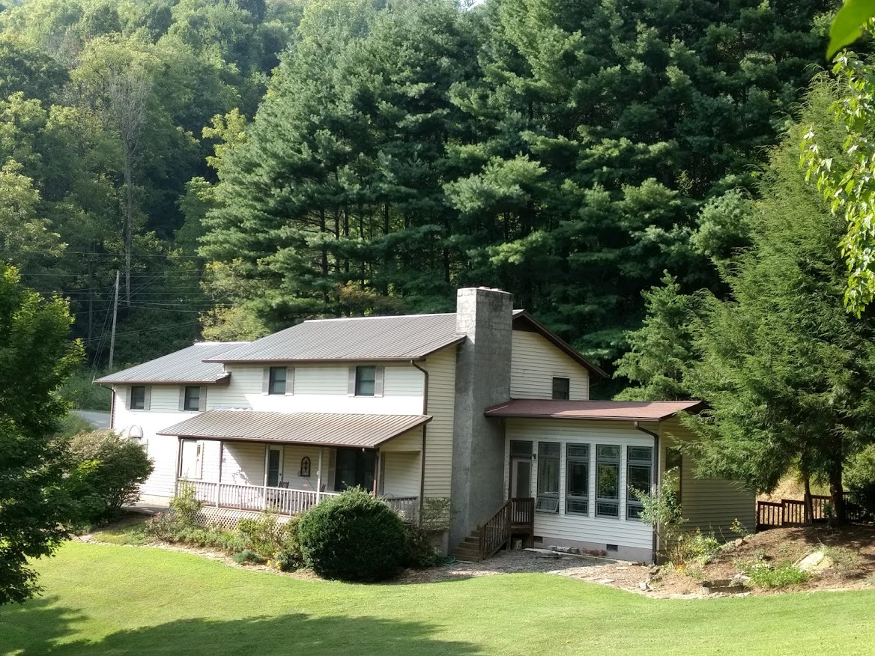
292 Green Meadow Lane
Mars Hill, NC – 28754
(828) 689-3290

Well maintained custom farm-style home in small subdivision. South facing and very private.
Large 2.93-acre lot with outdoor living space and a small storage shed. Lots of established landscaping. Exterior includes two decks, a front porch, a huge front field/lawn, forest areas.
Year-round long-range mountain views.
Home has oversized 2 car wood paneled garage with plenty of room for a workshop. 220-volt line installed.
Large master suite on main floor with passive solar heat. (This addition was built in 2009)
Eat in kitchen, formal dining room, living room with wood burning fireplace. ½ bath, pantry, and laundry also on main.

Upper floor has a huge bonus room / playroom, one more master bedroom, another bedroom, full bathroom and an office space. Must see all the storage space.

2 heat sources, zoned heat pumps, and baseboard fuel heat (both upstairs and downstairs)

City water – septic

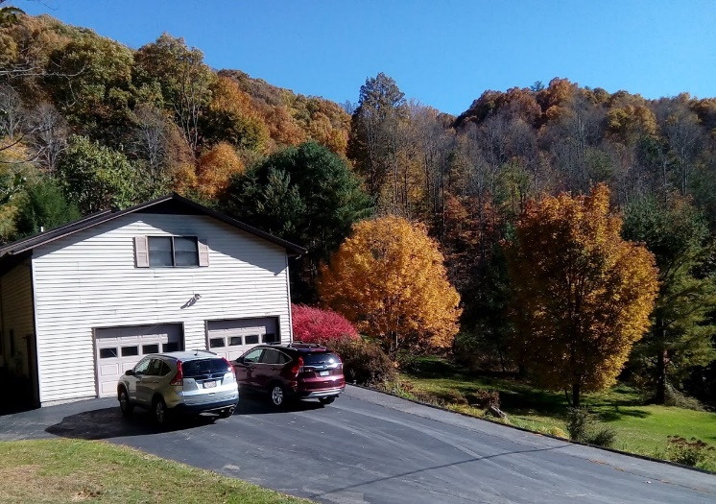
Total square footage: 2,980
Year built: 1991

Price: $ 399,000

