2023 Self-Service Benefit Enrollment Online
(Note: You must complete this process even if you are making no changes)
Log in to your MHU Self-Service using your MHU credentials.
You will see the Welcome screen seen below. Select Employee.

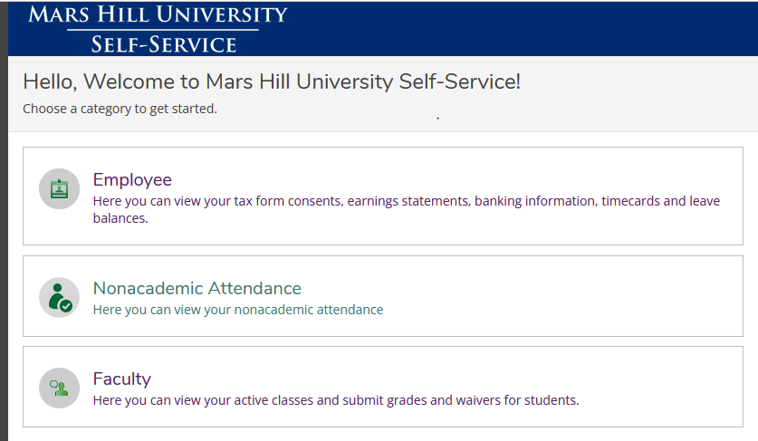

Next, select Benefits.
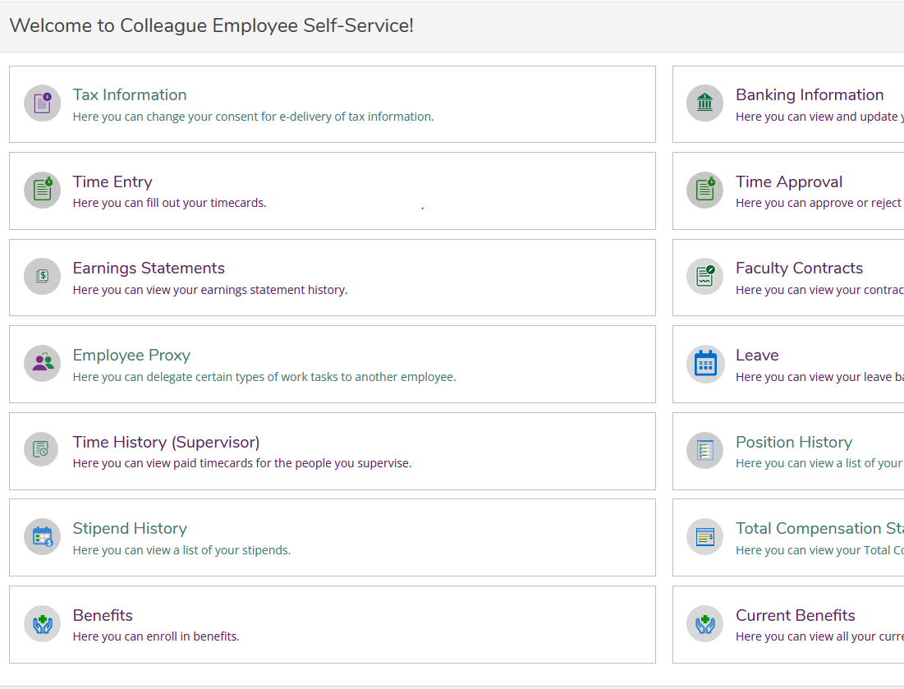

On the Benefits screen, first update your Dependents.

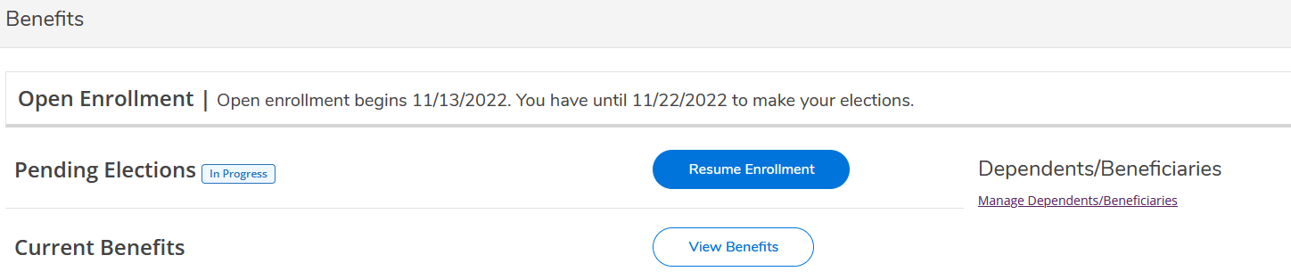

Any dependents currently enrolled or dependents you wish to enroll in benefits for 2023 should be listed on this screen. Please do not type over a dependent’s information who is already listed. To add a dependent, please select Add Another. For 1095-C reporting purposes, please make sure that your dependents have a date of birth and social security number on their file. To edit an existing dependent’s date of birth or social security number select the pencil icon to the right of their name under Action.

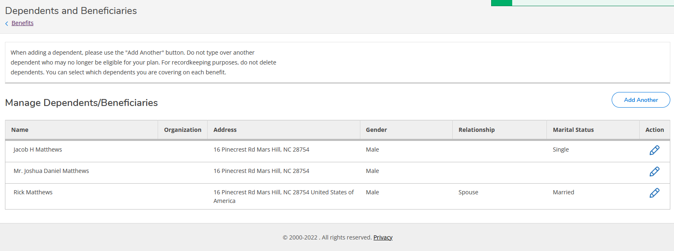
Once complete, select <Benefits in the upper left of your screen.

On the Enrollment screen, if you are waiving a benefit or all benefits, you will use the toggle switch to the right of the benefit. You may update your current plan or choose a plan to the right of the benefit.

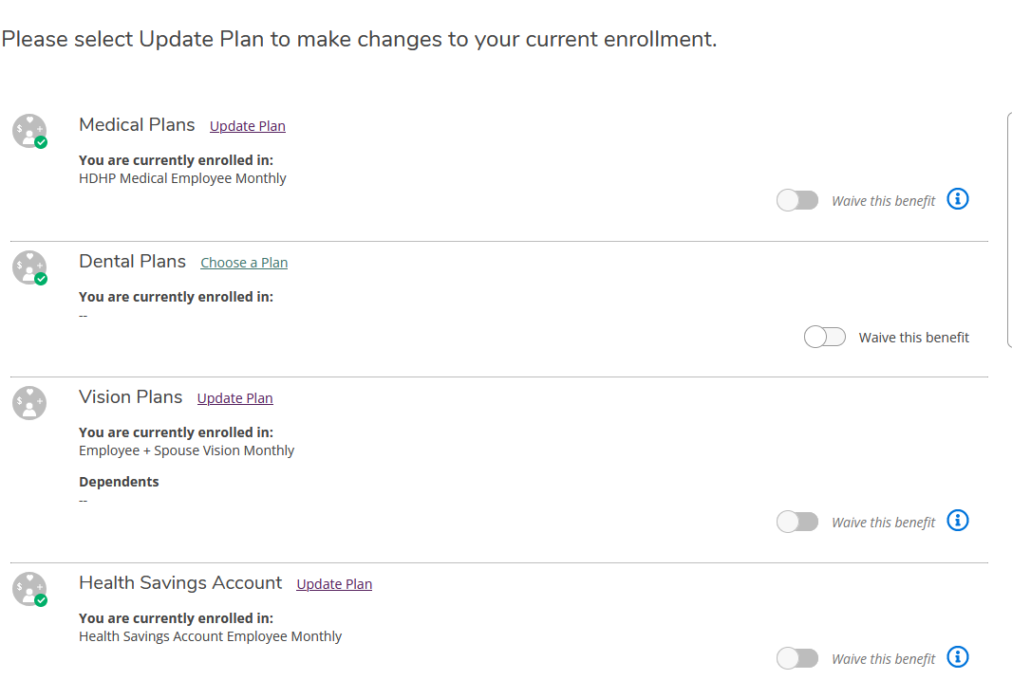
Only available for HDHP

Once you have completed all of your selections, the Review and Submit button will be active (blue) and you can review and submit your benefit elections.

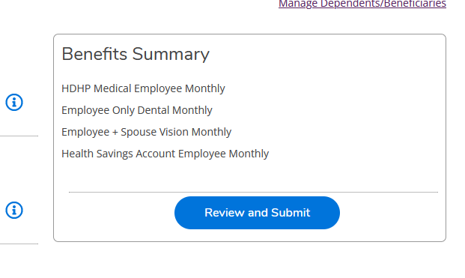

The Review and Submit screen will appear. Review your benefits and acknowledge the Terms and Conditions. Once you have read and accepted the terms, the submit button will be active (blue) and you can submit.
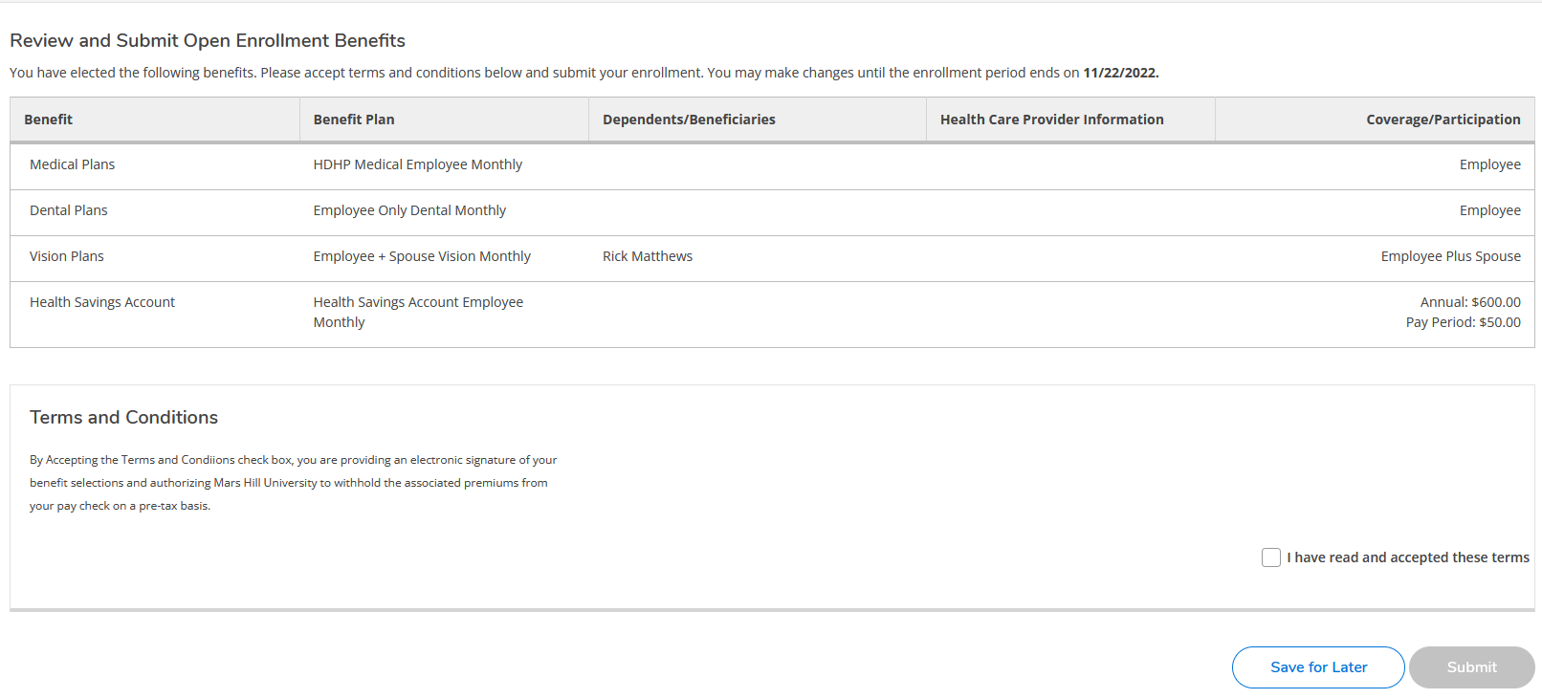
Upon submission, your confirmation screen will appear. Please Download PDF for your records.

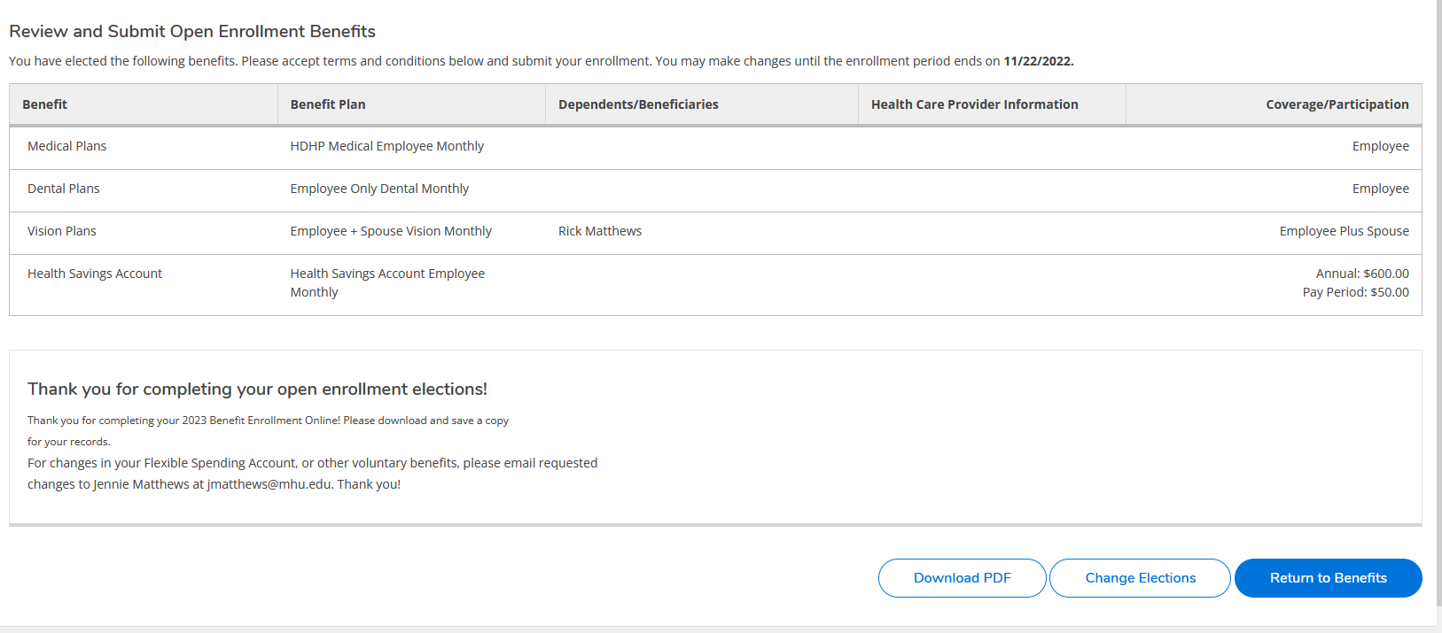
You may return to benefits and make any changes to your benefit elections until 5pm on Tuesday, November 22nd. Open enrollment will close at that time.
For changes to your Flexible Spending Account, Short-term or Long-term disability, Term Life Insurance, Critical Illness Plan, or Accident Plan, please contact Jennie Matthews at jmatthews@mhu.edu .
